**Continuous Discovery: Teressa Torres**

Continuous Discovery will answer the following questions:

* How do you know that you are making a product or service that your customers want?
* How do you ensure you are improving it over time?
* How do you guarantee that your team is creating value for your customers in a way that creates value for your business?

Discovery: What to build

Delivery: How to build

Continuous Discovery framework enables

* Teams to discover brand-new products and to iterate on existing ones
* Helps you continuously discover unmet customer needs and the solutions that will address those needs

Product Managers bring the business context: They help teams ensure that the products they are building are viable for the business

Prerequisite mindset to adopt continuous Discovery Habit:

1. Outcome oriented: Outcome rather than outputs
2. Customer-centric: The purpose of the business is to create and serve a customer
3. Collaborative: Decisions made by the Trio (PM,UX and Engg)
4. Visual: Draw to externalize your thinkings and to map what you know
5. Experimental: Learn to think like scientists identifying assumptions and gathering evidence
6. Continuous: Discovery through out your development process

Definition of CD:

At a minimum, weekly touchpoints with customers

By the team building the product

Where they conduct small research activities

In pursuit of a desired outcome

Doing research that can serve the customers in a way that creates value for the business

Opportunities: Customer needs, pain points and desires

Opportunity Space: Represent the problem space as well as the desired space

Ill-structured problem (Wicked Problem): Finding the best path to your desired outcome

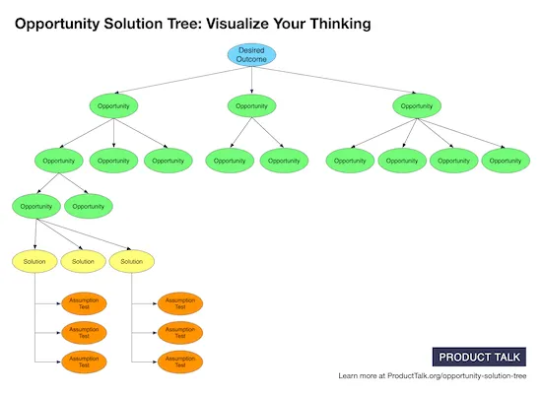

* Opportunity solution trees are a simple way of visually representing the paths you might take to reach a desired outcome.
* The root of the tree is your desired outcome—the business need that reflects how your team can create business value. Next is the opportunity space. These are the customer needs, pain points, and desires that, if addressed, will drive your desired outcome.
* Below the opportunity space is the solution space. This is where we’ll visually depict the solutions we are exploring.
* Below the solution space are assumption tests. This is how we’ll evaluate which solutions will help us best create customer value in a way that drives business value.

Opportunity solution trees help you resolve the tension between business needs and customer needs. You start by prioritizing your business need—creating value for your business is what ensures that your team can serve your customer over time.

4 Villains to poor decision making:

1. Looking too narrowly at the problem
2. Confirmation bias: looking for evidence that confirms our beliefs
3. Letting our short-term emotions affect our decisions
4. Over confidence

Avoid ‘Whether or not’ decisions: Should we do this or not

Sharing discovery work with stakeholders:

When sharing your discovery work with stakeholders, you can use your tree to first remind them of your desired outcome. Next, you can share what you’ve learned about your customer, by walking them through the opportunity space. The tree structure makes it easy to communicate the big picture while also diving into the details when needed. Your tree should visually show what solutions you are considering and what tests you are running to evaluate those solutions. Instead of communicating your conclusions (e.g., “We should build these solutions”), you are showing the thinking and learning that got you there

Business Outcome: measures how well the business if progressing

* Starts with financial metric like grow revenue or reduce costs or strategic initiatives like grow market share in a specific region or increase sales to a new customer segment

Product Outcome: measures how well the product is moving the business forward

* Product Trios make progress on a product outcome than a business outcome. Product outcome is within the Trio’s span of control. Business outcomes requires coordination across many business functions

Traction Metrics: Measures the usage of a specific feature or workflow in the product

Setting a team’s outcome should be a two-way negotiation between the product leader (e.g., Chief Product Officer, Vice President of Product, etc.) and the product trio.

But to be clear, the product leader should not be dictating solutions. Instead, the leader should be identifying an appropriate product outcome for the trio to focus on.

The product trio brings customer and technology knowledge to the conversation and should communicate how much the team can move the metric in the designated period of time (usually one calendar quarter).

A research suggests that product trios, when faced with a new outcome, should first start with a learning goal (e.g., discover the opportunities that will drive engagement) before being tasked with a performance goal (e.g., increase engagement by 10%).

Product trios tend to fall into four categories when it comes to setting outcomes:

1) they are asked to deliver outputs and don’t work toward outcomes (this is, by far, the most common scenario);

2) their product leader sets their outcome with little input from the team;

3) the product trio sets their own outcomes with little input from their product leader;

4) the product trio is negotiating their outcomes with their leaders”

Start with the desired outcome

The purpose of customer interviewing is not to ask your customers what you should build. Instead, the purpose of an interview is to discover and explore opportunities.